Lab 01 - .NET - Dev - Creating and deploying a web app using Azure App Service
Estimated Duration: 25 minutes
Lab Type: Instructor led
Objective
In this lab, you will learn how to deploy an ASP.NET Core API app to Azure App Service. App Service supports various versions of .NET apps, and provides a highly scalable, self-patching web hosting service. ASP.NET web apps are cross-platform and can be hosted on Linux or Windows.

Exercise 1: Getting the GitHub account and resources ready

Task 1: Create a new GitHub account
Note: If you already have an account with GitHub, you can login to your GitHub account, ignore this task and continue with the next task.
- Open https://github.com/ from your browser.
- Click on Signup.
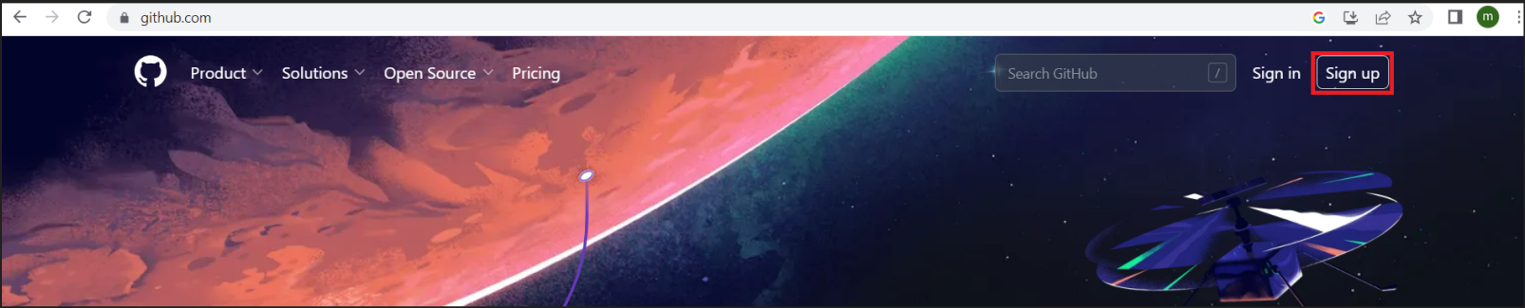
- In the Enter your email in the textbox provided, enter you email id and then click on Continue.
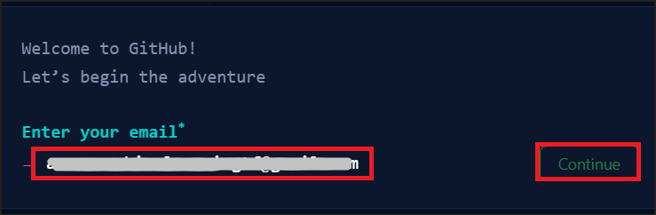
- Create a password, enter a user name and then click on Continue.
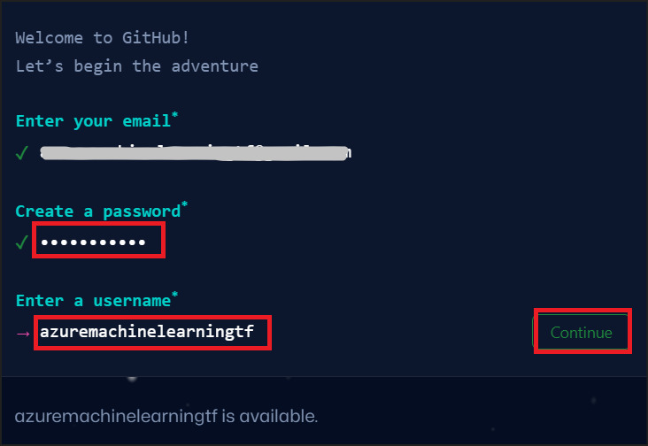
- Solve the puzzle. Click on Create account.
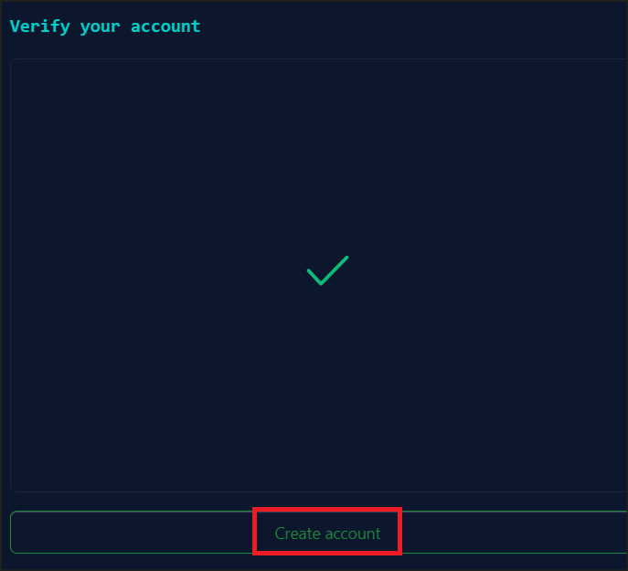
- Enter the validation code that is sent to your registered email address.
- Select Skip this for now in the What do you want to do first page.
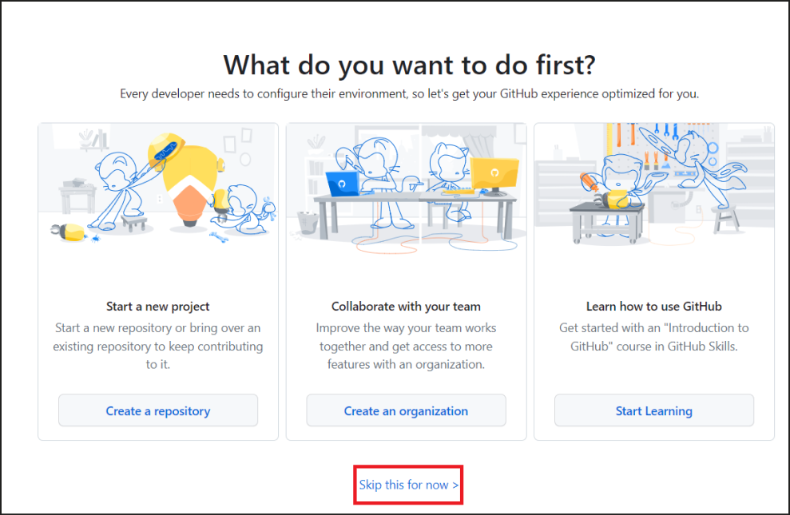
- The Home page opens up.
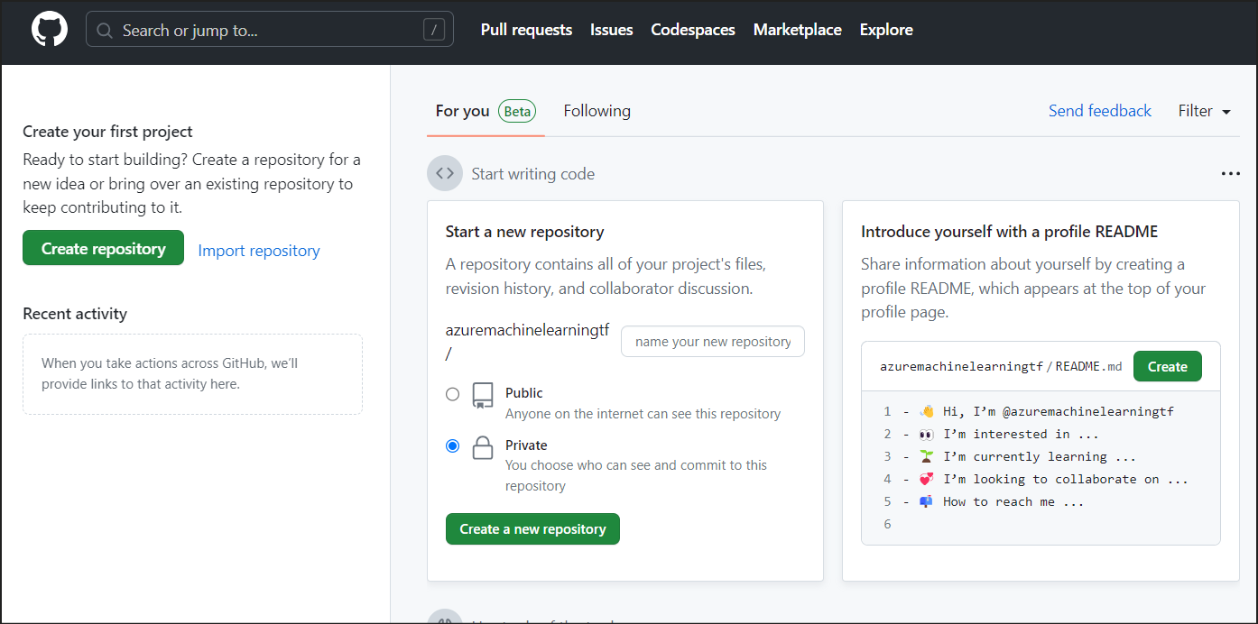
Note: Keep a note of the email address you had used for the registration and the username and password.

Task 2: Fork the repo dotnet-core-api demo into your GitHub account
- Open a browser and enter this link - https://github.com/getazureready/dotnet-core-api.
- Select the Fork button in the upper right on the GitHub page and then select the option Create a new fork.
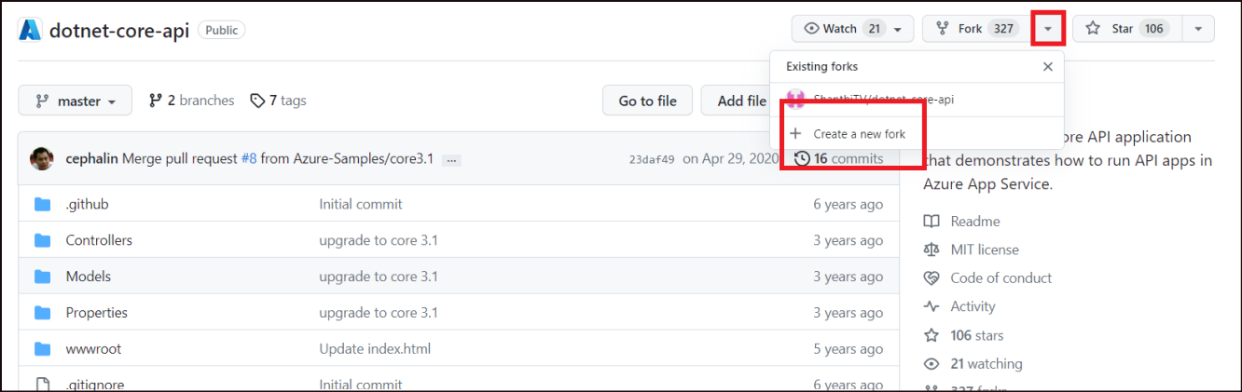
- Select Create fork.
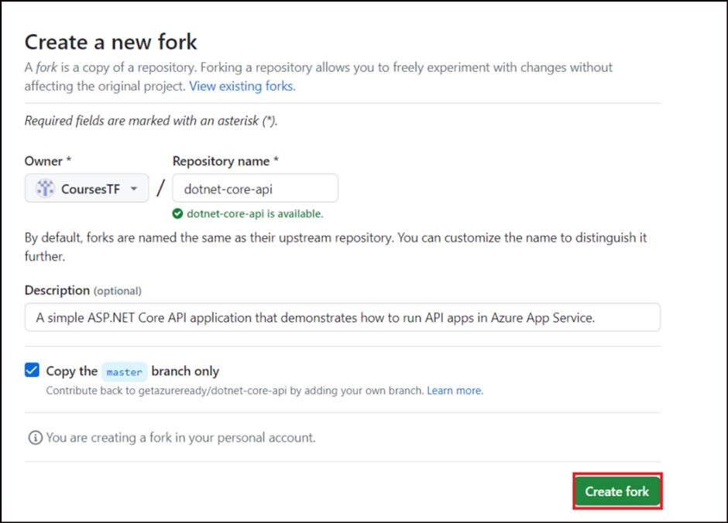
- This is the sample application that you will be deploying to Azure.
- From the home page of the forked app, click on Actions.
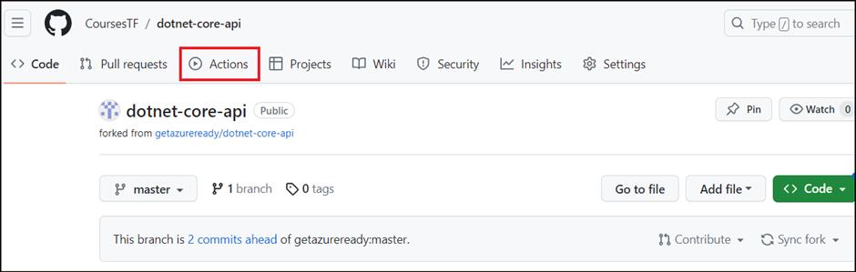
- On the Actions page, if there are any Workflows listed under All workflows, click on each one of them, click on the three dots, select Disable workflow.
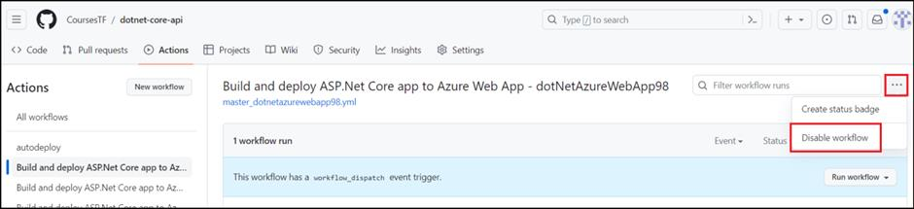
- This is to avoid any older workflows being executed unwantedly.

Exercise 2. Publish your web app
To publish your web app, you must first create and configure a new App Service that you can publish your app to.
As part of setting up the App Service, you create:
- A new resource group to contain all the Azure resources for the service.
- A new Hosting Plan that specifies the location, size, and features of the web server farm that hosts your app.

Task 1: Create the App service plan and app in Azure
Follow these steps to create your App Service resources and publish your project:
- Open a new browser and login to Azure at https://portal.azure.com using the Username and Password under Office 365 Tenant from the Resources tab. This will be your login credentials to Azure throughout the labs.
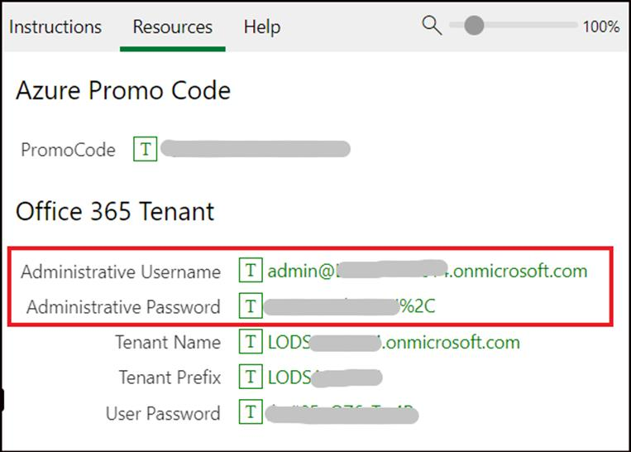
- Type app services in the search bar. Under Services, select App Services.
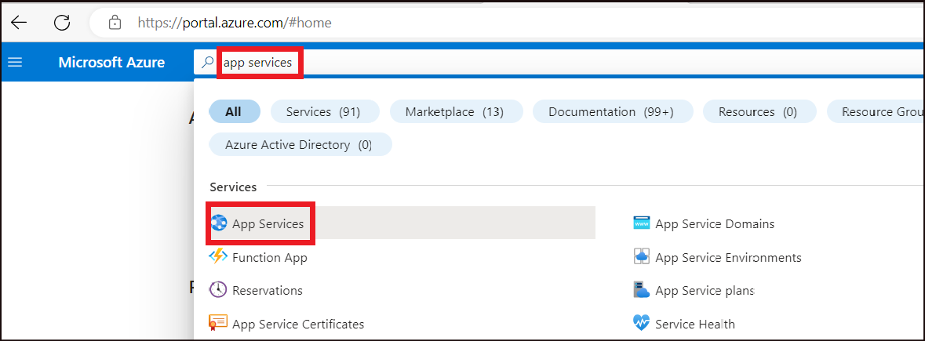
- In the App Services page, select the drop down next to + Create and then select Web App.
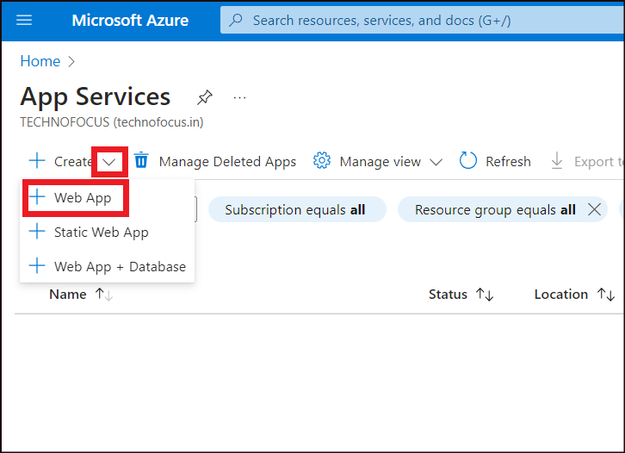
- In the Basics tab -> Project Details, enter the below details.
Property | Value
Resource Group | Create New -> RGForAppService and click OK.
- 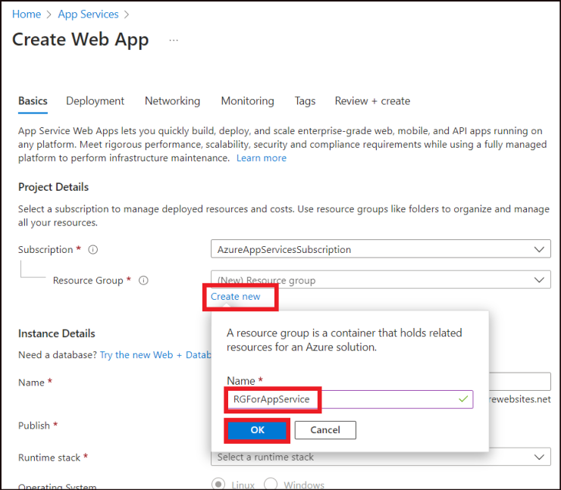
- In the Basics tab -> Instance Details, enter the below details.
Property | Value
Name | dotNetAzureWebAppXX (This name should be globally unique. Replace XX with any random number to ensure uniqueness)
Publish | Select Code
Runtime stack | Select .NET 7 (STS)
Operating System | Windows
Region | East US
- 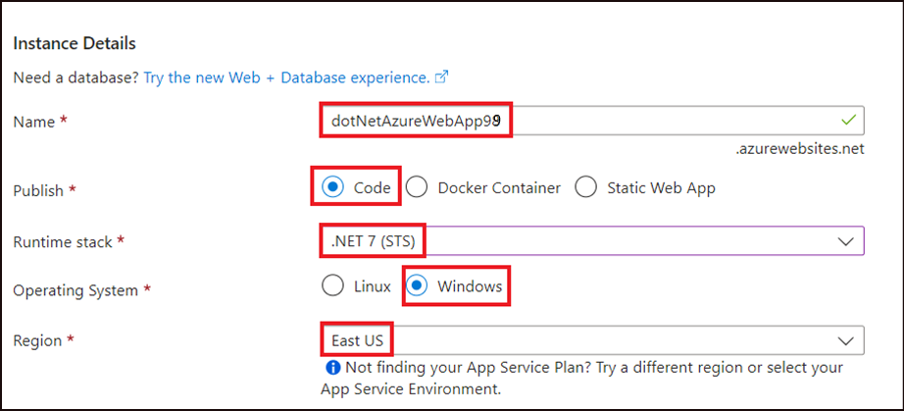
- In the Basics tab ->Pricing plans, enter the below details.
Property | Value
Windows Plan | Create new ->myAppServicePlan
Pricing plan | Premium V3 P1V3
- 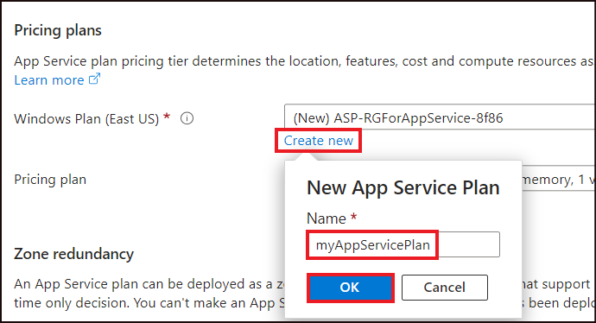
- 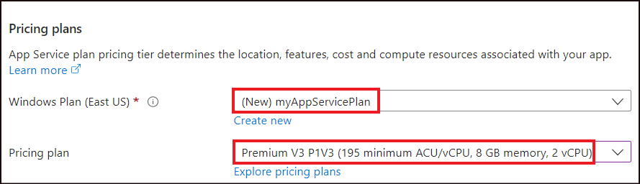
- Select Disabled for Zero redundancy and then click on Next: Deployment.
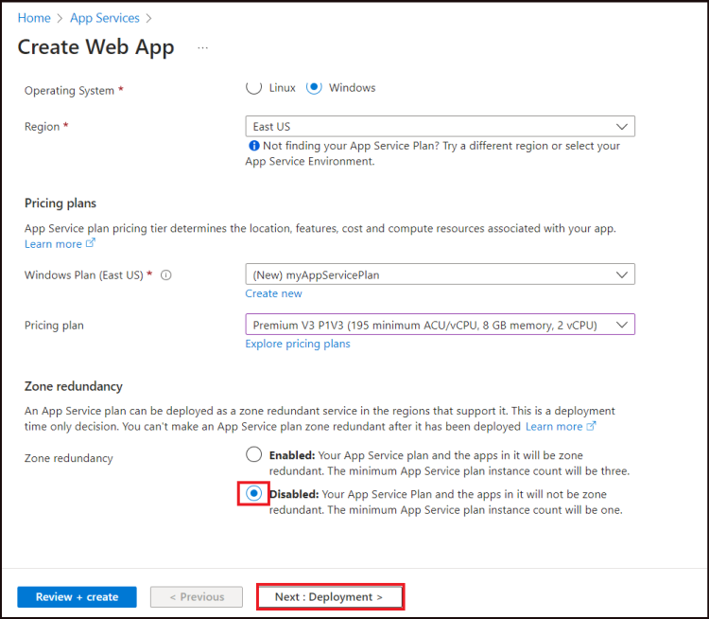

Task 2: GitHub Actions that enables Continuous deployment
Workflow file overview:
A workflow is defined by a YAML (.yml) file in the /.github/workflows/ path in your repository. This definition contains the various steps and parameters that make up the workflow. The file has three sections:
Section | Tasks
Authentication | 1. Define a service principal or publish profile. 2. Create a GitHub secret.
Build | 1. Set up the environment. 2. Build the web app.
Deploy | 1. Deploy the web app.
There are different ways to implement Continuous integration. Here, we are using the Deployment Center to implement the same.
- In the Deployment tab, select Enable the Continuous deployment under GitHub Actions settings.
- Under GitHub Actions details, click on Authorize.
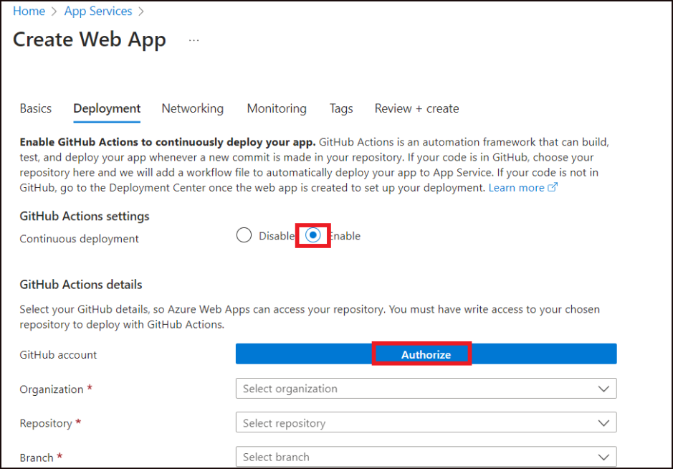
- Clicking on Authorize will take you to the Authorize page to login to GitHub. Click on Authorize AzureAppService.
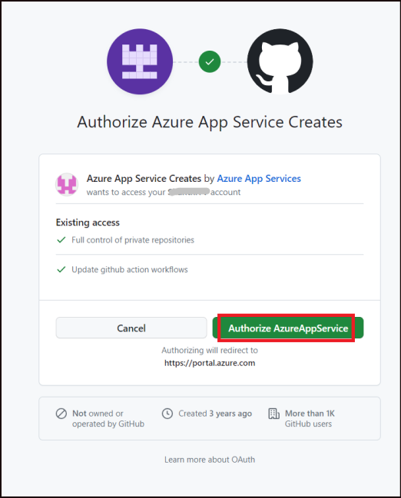
- Click Confirm on the Confirm access page.
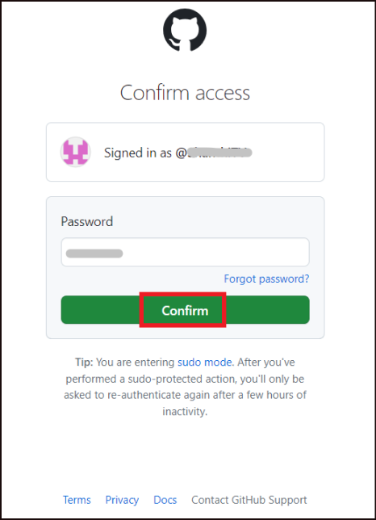
- Authenticate with your GitHub account, and select the following options:
Property | Value
Organization | Select your Github account name
Repository | Select dotnetcore-core-api
Branch | master
- Select Next : Networking >.
- 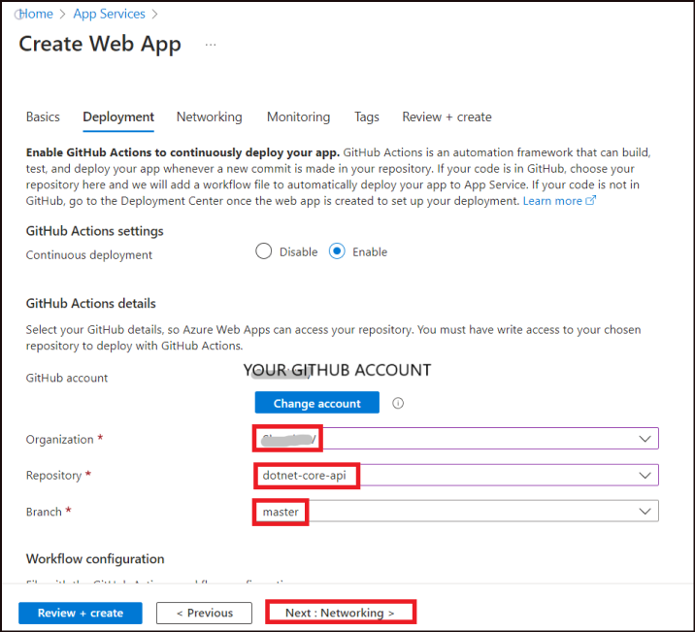
- This will ensure that, each time an update is made to the app, the workflow gets triggered automatically and the app is deployed.
- On the Networking tab, accept the defaults and click on Next : Monitoring > .
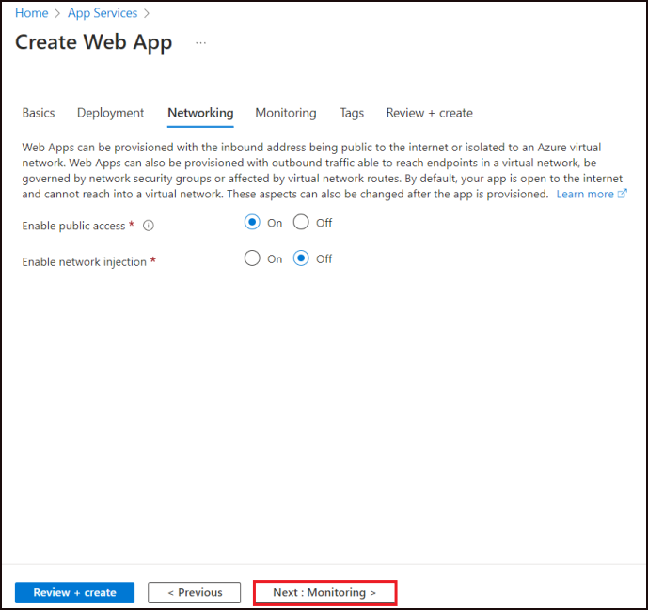
- On the Monitoring tab, ensure that Yes is selected for the Enable Application Insights option. Select Review + Create.
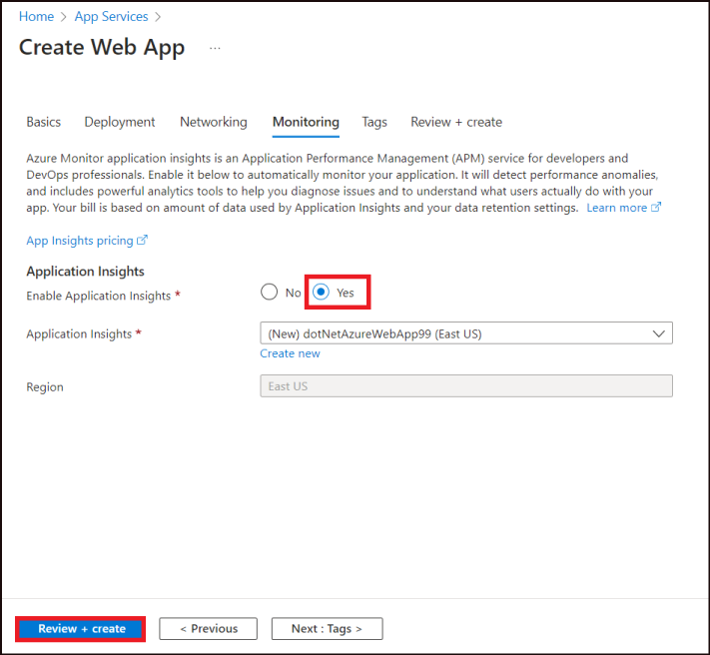
- Once validated, select the Create button at the bottom of the page.
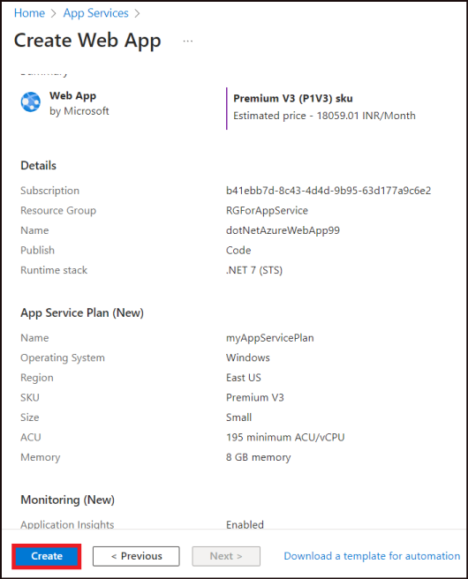
- After deployment is complete, select Go to resource.
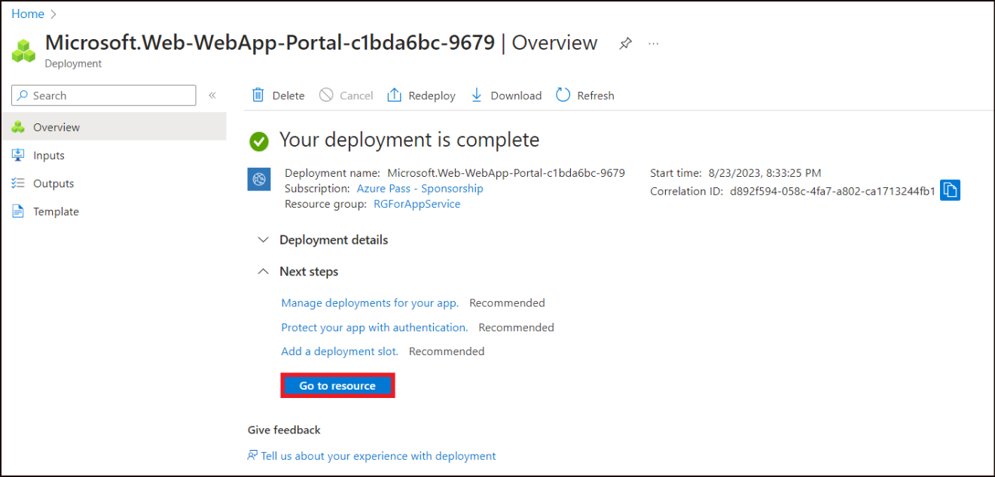
- This is the place to manage the web app. The Default domain name gives the url for the app. Click on it.
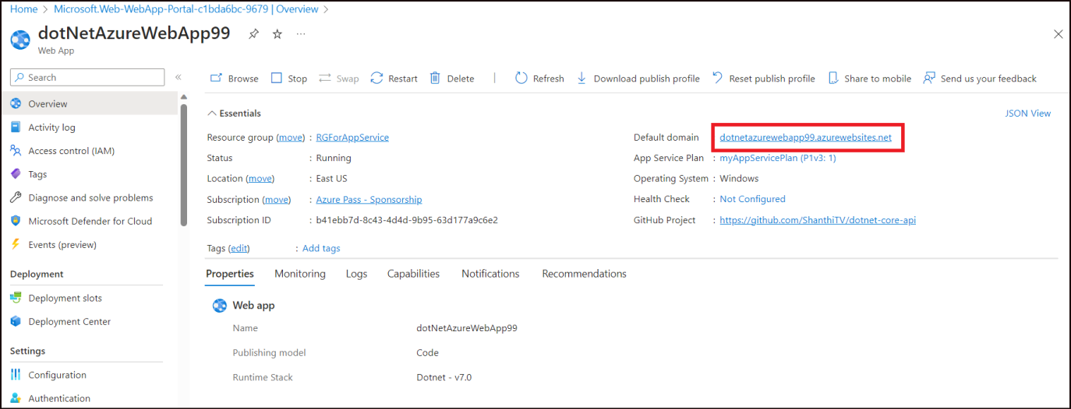
- It opens up the app that we have deployed in Azure.
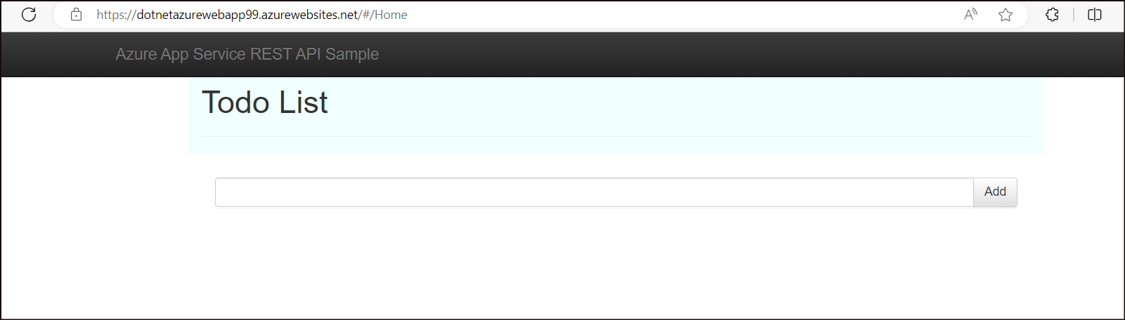

Exercise 3: Test the Continuous Deployment
- From the forked repo in the Github, select index.html under wwwroot.

- Click on the Pencil icon and then select Edit in place.
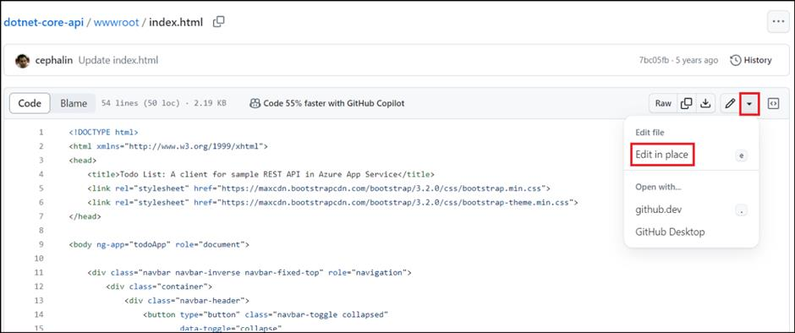
- Look for the Todo List in line 32 and update it to be Todo List Continuous Deployment. Click on Commit Changes.
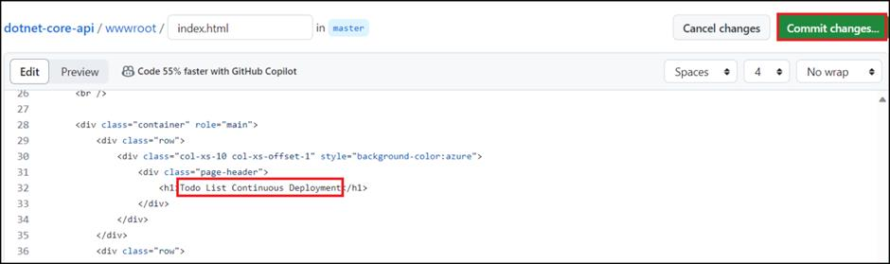
- Click on Commit changes.
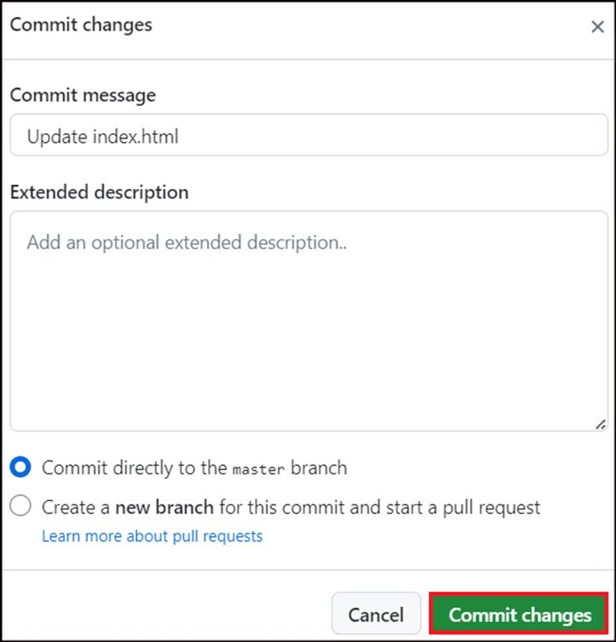
- Select Actions.
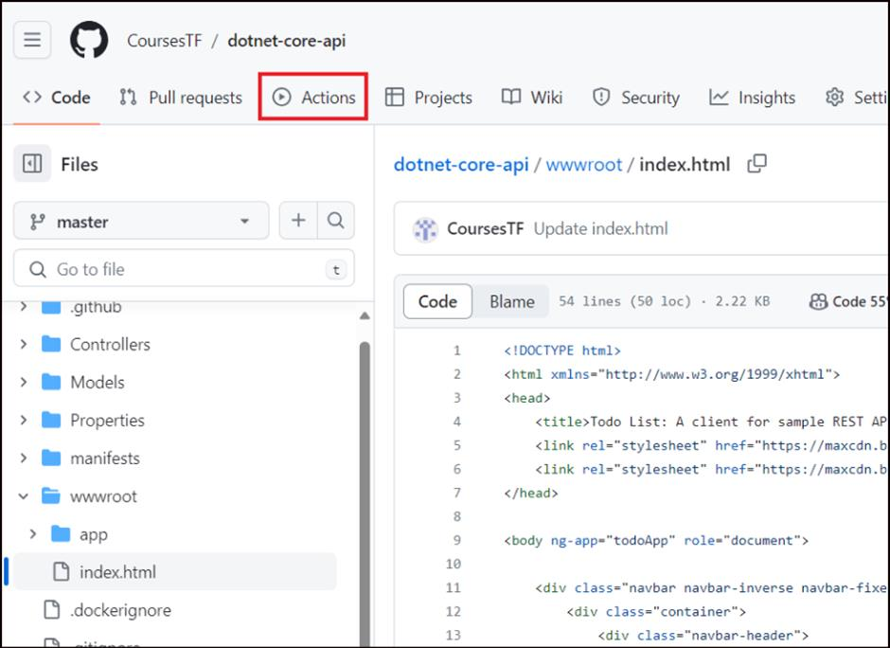
- Find the workflow with the name Update index.html is in progress. This is the workflow that has been triggered because of the commit that we have made to the index.html file.
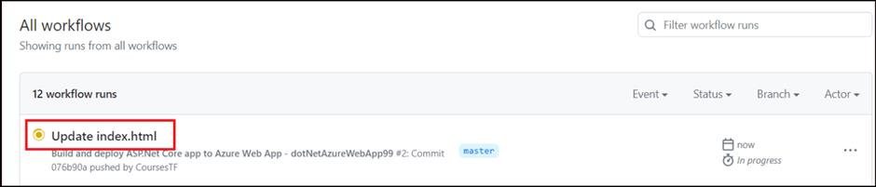
- Click on it and view stages of Build and Deploy getting executed.
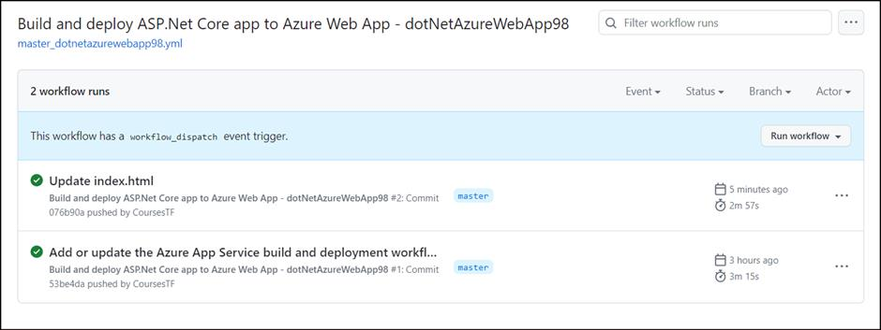
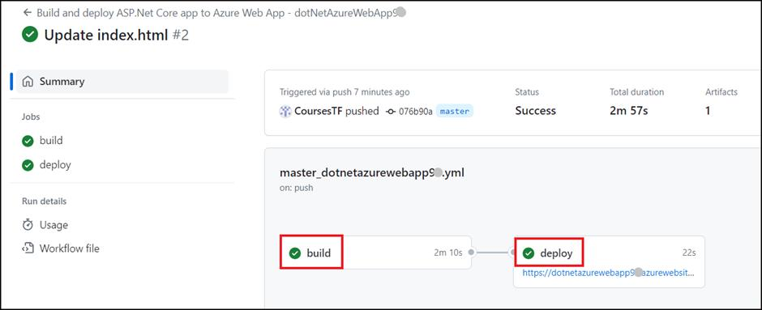

Exercise 4: Access the app
- Navigate to the app url (https://dotnetazurewebappXX.azurewebsites.net/#/Home) again.
- Find that the title has been updated. 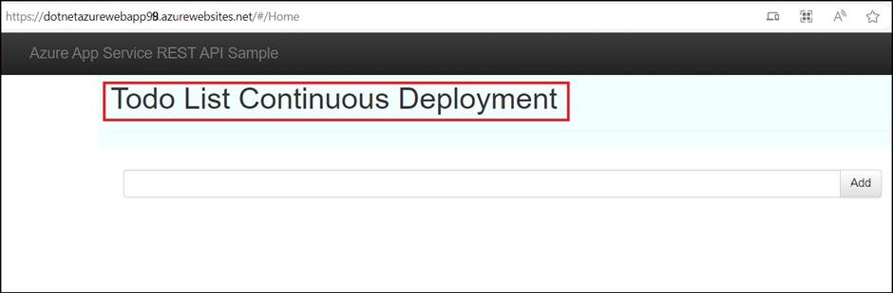
Summary:
You have successfully completed deploying the web app to Azure. Now, you have an Azure resource group consisting of an App Service hosting plan and an App Service with a deployed web application.

